How to Be a Good Audience Member

Teachers, please share this with school age students prior to bringing them to a performance at the Center for the Performing Arts. It supports the acquisition of knowledge and skills they need to recognize that the environment of the observer influences individual aesthetic responses to works in the arts (Pennsylvania Academic Standards for the Arts and Humanities 9.4.3.C).

A theatre is a charged space, full of energy and anticipation. When the house lights (the lights that help you see around you) go down, the excitement level goes up! Theatres are designed so that the voices and music of the performers can be heard. But this also means that any sound in the audience (that’s you!)—whispering, crunching your papers, talking, wiggling—can be heard by other audience members and by the performers. This can spoil a performance for the other audience members and for the performers.

The performers on stage show respect for their art form and for you, the audience, by doing their very best possible work. You show respect for the performers by looking and listening carefully.

Applause (clapping) is the best way for you to share your enthusiasm and to say thank you to the performers. Applaud at the end of a performance! Sometimes the audience will clap during a performance or after a performer does something by him or herself (a solo). Audience members may feel like laughing if the action on stage is funny or crying if the action is sad. You can show respect for the performers in many different ways, depending on the performance. You might sit quietly at a dance performance. You might clap and sing at a music performance.

At the end of the performance, the cast will take a bow for what’s known as a curtain call. Reward them by acknowledging them with your applause. At this time you many rise from your seat to give a standing ovation.
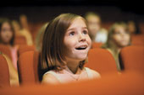

Best Practices for Watching-- school age
- Notice how costumes and lights add to the performance.
- Show the performers your respect. Do not talk or whisper during the performance. Open food, drinks and gum are not allowed in the theatre. Using cell phones—including text messaging—is forbidden.
- Listen carefully and watch closely.
- Clap at the end! The performers will take a bow. If you really like it, give the actors, musicians or dancers a standing ovation (rise from your seat and clap really hard)!
- Enjoy! The performers perform for you. They have worked very hard to bring the production to the Center for the Performing Arts and to share it with you.

Best Practices for Watching--preschool age

Teachers, please share this with preschool age students prior to bringing them to a performance at the Center for the Performing Arts. It shows what preschoolers need to know to appreciate theater arts (Pennsylvania Learning Standards for Early Childhood: Arts and Humanities 9.4).

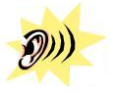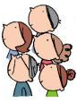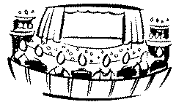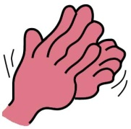

Watch Listen Audience Show Clap Like

Hooray! You are going to a performance at the theatre!

When you and to a performance, you are part of the . The is an important part of the .

To hear all the sounds of the performance,

the must carefully! If you talk, other people in the will not be able to hear. When the performance ends,

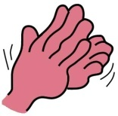to let the performers know you the .

